**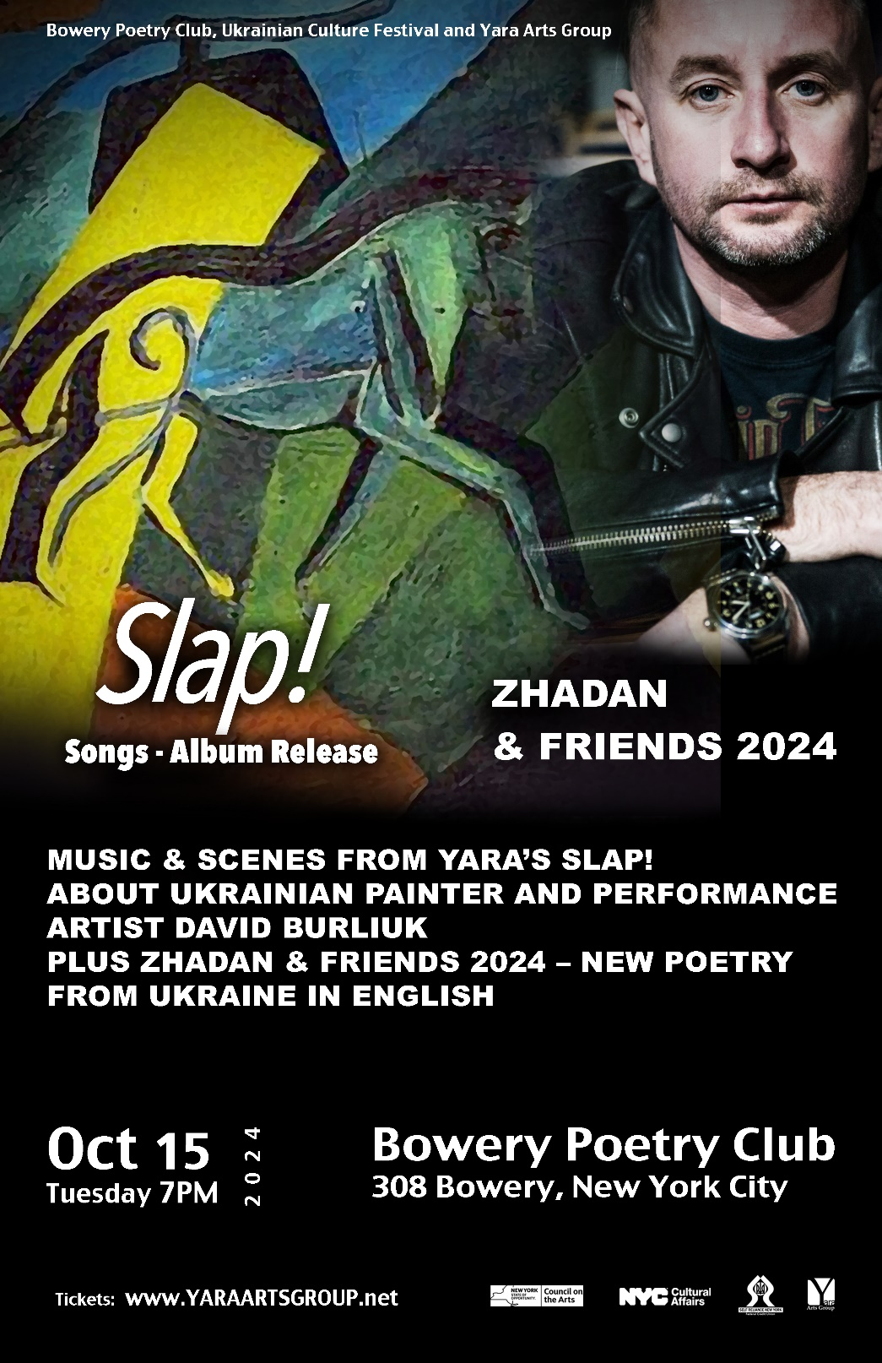**

**Yara Arts Group’s**

**SLAP! Songs Album Release Party**

**&**

**ZHADAN & Friends 2024**

**New poetry from Ukraine**

**SCENE & SONGS FROM *SLAP!   
about Ukrainian painter and father of Futurism David Burliuk***

with Bob Holman, Susan Hwang & Julian Kytasty, directed by Virlana Tkacz  
projections by Darien Fiorino

**DAVID BURLIUK** was a painter, poet and the energetic organizer of Futurism. He was born in 1882 near Kharkiv area in eastern Ukraine. His father managed the largest estate with horse in the Kherson area, called Hylaea by the ancient Greeks. He studied in Odesa, Kazan, Munich and Paris. Burliuk’s early paintings show Cubist influences, as well as a fascination with Scythian culture. He took part in many excavations of the Scythian burial mounds that dot the Kherson area. He founded the artistic group Hylaea. Burliuk’s favorite character was Mamai, who embodied for him a vision of self-sufficiency. Burliuk was an active participant in important avant-garde exhibitions in Kyiv, Moscow, St. Petersburg and Munich. With the Futurists, Burliuk toured 17 cities. They drew packed houses, scandalizing some, but also winning converts. During the revolutionary years, he traveled to Siberia, giving Futurist performances. From 1920 to 1922 he spent time in Japan. In 1922, Burliuk arrived in New York. He died in Long Island in 1967.

|  |  |  |
| --- | --- | --- |
| Meet Mamai | Music & text by Julian Kytasty | Performed by Julian Kytasty on bandura |

Julian: Scene 1 The Young David Burliuk, not yet the father of Futurism, in his first summer in the steppes of Southern Ukraine. He and his brothers are exploring a Scythian Mound.

|  |  |  |
| --- | --- | --- |
| A Rude Awakening | “I’ll Let My Horse Run Free” traditional Ukrainian song deformed by Julian Kytasty | Performed by Julian Kytasty on bandura |
| Viper Woman | Music & lyrics by Susan Hwang | Performed by Susan Hwang on accordion |

Julian: Scene2-8 Burliuk goes to Paris, returns to copy the cubists, is schooled by yours truly and slapped by the Scythian Viper Princess. He understands the toured

Future is Ancient. He Slaps the Face of Public Taste all over the Empire until it collapses. But the Reds arrest the anarchists, so he leaves East by train one step ahead of the warring armies staging Futurist shows and exhibitions in Siberia.

|  |  |  |
| --- | --- | --- |
| Tatlin Music | Music by Julian Kytasty | Performed by Julian Kytasty on bandura |

Julian: Finally, he arrives in the World’s First Futurist City!

|  |  |  |
| --- | --- | --- |
| Vladivostok | Lyrics by Bob Homan, music by Susan Hwang | Performed by Susan Hwang, Bob Holman & Julian Kytasty |

Scene 9 Vladivostok Oct 1919 Cabaret Bi-Ba-Bo, the wildest club in the hottest town on the planet!

|  |  |  |
| --- | --- | --- |
| Bi-Ba-Bo | Music & lyrics by Susan Hwang | Performed by Susan Hwang on accordion, Bob Holman & Julian Kytasty |
| Burliuk’s Entrance | Text by Bob Holman | Performed by Bob Holman |

Julian: Scenes 10-12 Burliuk leaves Vladivostok to present the first Futurist exhibition is Japan and looks into the caldera of Mt Mihara volcano before departing for the East Village. 1922 -- Burliuk walks the streets of New York.

|  |  |  |
| --- | --- | --- |
| Radio Manifesto | From “A Radio Manifesto from a Futurist to the Future” by David Burliuk (1926). Music by Susan Hwang | Performed by Bob Holman, with Julian Kytasty and Susan Hwang |

**BUY the Slap Songs! Album & get your Scythian Tattoo!**

**ZHADAN & FRIENDS 2024**

**SERHIY ZHADAN** is one of Ukraine most celebrated writers. In 2022 he received the Hannah Arendt Prize for Political Thought, the German Peace Prize and nine international literature prizes. His books available in English include: *The Orphanage, Mesopotamia* and *What We Live for, What We Die For: Selected Poems* ([Yale University Press](https://yalebooks.yale.edu/search-results/?keyword=serhiy+zhadan)). Serhiy was born in Luhansk, Ukraine's easternmost region and lives in Kharkiv. He has worked with Yara Arts Group since 2005, including the award-winning show *1917-2017: Tychyna, Zhadan & the Dogs*. He is the front man for his band Zhadan & the Dogs.

Poetry by Serhiy Zhadan translated into English by Virlana Tkacz & Wanda Phipps

**“There will be a moment…” “ A glow from a twig” and “I love this woman”  
performed by Elias Husiak & Anastasiia Panchenko**

**“Schulz Psalms”**

**performed by Olga Livshin, Bob Holman, Marina Celander & Wanda Phipps**

**“They didn’t tell you….”**

**performed by George Drance and Silvana Gonzalez**

**It’s worth remembering…”**

**performed by Serhiy Zhadan and Wanda Phipps**

**“Light” music by Susan Hwang, performed by cast**

**PERFORMERS**

**MARINA CELANDER** is a theatre artist, singer and movement artist. Her performance creations *Tree She, Sea She* and *Stone She*, were shown at various festivals in NYC and Brooklyn. Stone She was presented at LaMama Moves 2022, a meditation on our state of the world and what we do as women to find our witchery to overcome and heal. Marina is thankful to perform with Yara Arts Group again.

**GEORGE DRANCE** has performed and directed in over 25 countries on five continents. He is Artistic Director of the critically acclaimed Magis Theatre Company. Theatre credits include: Metropolitan Opera, The Public, ImprovBoston, American Repertory Theatre, and La MaMa ETC - including Ping Chong + Company, *The Trojan Women Project* and as a close collaborator of Ellen Stewart. Television credits include: *The Daily Show*, and *Blacklist*. He is an Artist-in Residence at Fordham Lincoln Center.

**DARIEN FIORINO** (performer & projections) appeared in Yara’s *A Thousand Suns, Koliada on Mars, Forest Song,* and *1917-2017: Tychyna .Zhadan & the Dogs* at La MaMa which garnered two New York Innovative Theatre Awards. He has been working on *SLAP!* With Yara since 2019.

**SILVANA GONZALEZ** is a Mexican actress and classical ballet dancer who graduated from NYU Tisch with a Founders Day Award and BFA in Theater. Her theater credits include Ondine in *A Thousand Suns* with Yara, Hera in *FauxBia*! The Musical at Carnegie Hall, Milenia at *The Lucille Lortel*, Hermia in *A Midsummer Night´s Dream*, Cynthia in *WarLovers* at Theater Row, and Louise Overbee in *Love/Sick*.. Silvana is a member of the NYC theater company Something From Abroad and honored to be working with Yara again.

**BOB HOLMAN** is a poet most often connected with the oral tradition, spoken word, poetry slams and digital poetry. His most recent books include India Journals, to accompany the film he wrote and hosts, Ginsberg’s Karma; and Life Poem and The Unspoken, two books of poetry written 50 years apart. As an actor, he originated and

in Stories Left to Tell: Spalding Gray and created the part of Captain John Smith in Yara’s *Capt. John Smith Goes to Ukraine*. He also performed in *1917-2017: Tychyna Zhadan & the Dogs at La MaMa and “Radio477!”* He created two award-winning PBS series, The United States of Poetry, and the documentary on endangered languages, Language [www.bobholman.com](about:blank)

**ELIAS HUSIAK** is a NYC born-and-raised actor, singer, director and co-founder of East Village Basement. This Winter, he'll be acting in the new production of *AIDA* at The Metropolitan Opera. Graduate of The Neighborhood Playhouse and Ithaca College (BFA Musical Theatre) IG: @elihusiak -- www.[eliashusiak.com](http://eliashusiak.com/).

**SUSAN HWANG** tells stories and makes collapsible things like songs and times.  She plays accordion, janggu (Korean drum) and piano, but physical objects she can’t play, wear or eat intimidate her.  She’s the founder/producer of international, literature-inspired arts non-profit, [The Bushwick Book Club](http://bushwickbookclub.com/).  Not a great vacationer, she leaves NYC for theater and with bands like The Debutante Hour, [Lusterlit](http://lusterlit.com/" \t "_blank) and Soozee Hwang and The Relastics.  You can read her first illustrated story in “Coinky Dink” a zine produced by artist Yoko Oji Kikuchi.  Susan plays accordions because they’re lighter than pianos (barely) and drums because it's healthy for a girl to hit things. [susanhwanglalala.com](about:blank) lusterlit.com

**JULIAN KYTASTY** is a third -generation bandura player. He is both a keeper of traditions and an innovator who has opened new paths for his instrument. He has worked frequently with Yara Arts Group creating and performing music for theatre pieces, poetry performances, and festivals. His work on Yara’s *1917-2017 Tychyna, Zhadan, and the Dogs* earned him a NY Innovative Theater award for best original score. He continues to teach bandura to a new generation of students in North America and Ukraine, to record, to compose and arrange music for bandura, and to engage in collaborative projects.

**OLGA LIVSHIN’s** work is recently published in the *New York Times, Ploughshares, The Rumpus,* and other journals. She is the author of the poetry collection *A* *Life Replaced: Poems with Translations from Anna Akhmatova and Vladimir Gandelsman* (2019). Livshin co-translated *Today is a Different War* by the Ukrainian poet Lyudmyla Khersonska  (Arrowsmith Press, 2023) and *A Man Only Needs a Room* by Vladimir Gandelsman (New Meridian Arts, 2022). As a consulting poetry editor for *Mukoli: A Journal for Peace*, she reviews poetry from conflict-affected communities across the world.

**MAKSYM LOZYNSKYJ**  is a singer, songwriter, producer, and actor. He has been a member of Yara Arts Group at La Mama for over 10 years and has been involved in a number of productions.  He graduated from Berklee College of Music with a master’s in music production and has just finished scoring the soundtrack for a new movie set to premier in America.

**ANASTASIA PANCHENKO** worked with Yara Arts Group on the reading of *Blind Sight* summer 2023 and on *Mariupol: Diaries of War and the Tree of Life* at Howl Happening and the festivals last, as well as SLAP! this fall. She also appeared in a documentary performance *Are We There Yet?* with nine other teenagers from Ukraine at the New York Theatre Workshop . She volunteers for Razom.

**WANDA PHIPPS** (performer & co-translator) is a founding member of Yara and has been translating Ukrainian poetry with Virlana Tkacz since 1989. Together they have received the National Theatre Translation Award for their translation of *The Forest Song*, as well as numerous grants from the New York State Council on the Arts. Her books include *Mind Honey* (Autonomedia), *Field of Wanting: Poems of Desire* (BlazeVOX [books]), and *Wake-Up Calls: 66 Morning Poems* (Soft Skull Press). She curated several reading series at the Poetry Project at St. Mark's Church and has written about the arts for Boog City, Time Out New York and Paper Magazine.

**VIRLANA TKACZ** (director & co-translator) heads the Yara Arts Group and has directed almost forty original shows at La MaMa in New York, that also performed in Kyiv, Lviv, Kharkiv, Bishkek, Ulaanbaatar, and Ulan Ude. She received an NEA Poetry Translation Fellowship for her work with Wanda Phipps on Serhiy Zhadan’s poetry. Yale University published their second book of Zhadan’s selected poems *How Fire Descends*, last fall. Her production of *1917-2017: Tychyna Zhadan & the Dogs*” won the 2018 New York Innovative Theatre Awards for best musical.

**WALDEMART KLYUZKO** (projections and graphics) is an artist from Kyiv, Ukraine, who has collaborated with Yara Arts Group since 2010, most recently creating the set for *Radio 477!* He was nominated twice for innovative theatre design for NYIT Awards. He co-curated the Kurbas in Kyiv, Kurbas in Kharkiv and the Kurbas: New Worlds exhibition at the Mystetsky Arsenal.

**CHRYSTINA DEYCHAKIWSKY** (stage manager) moved to New York from Michigan, and this is her first show with Yara Arts Group.

**YARA ARTS GROUP** was established in 1990 and is a resident company at La MaMa, the acclaimed experimental theater in New York. Yara has created thirty-seven theatre pieces based on extensive research in Eastern Europe, Siberia and Asia, in Yara’s signature style of multilingual dialogue and songs supported by evocative visuals. Yara Arts Group is a resident theatre company of La MaMa Experimental Theatre in New York. **Yara Arts Group 306 East 11th St #3B, New York, NY 10003 (212)475-6474** [**www.yaraartsgroup.net**](http://www.yaraartsgroup.net): @yaraartsgroupinc instagram: @yara.arts

**Yara Arts Group is a resident company of La MaMa Experimental Theatre**. Special thanks to Bob Holman and the Bowery Poetry Club.

***This event***was made possible by public funds from the New York State Council on the Arts, New York City Department of Cultural Affairs and the Self Reliance Foundation, and the friends of Yara Arts Group.

See also **JULIAN KYTASTY, master of the bandura, performing trational & new work this week -- Wed & Thursday October 16 &17 7PM at the Reneee & Chaim Gross Foundation, 526 La Guadia Place West Village. Tickets on www.yaraartsgroup.net**